Scar Management
- Once your scar has fully formed (usually 2-3 weeks after surgery), you can begin scar massage and silicone sheeting to optimize its appearance.
- Scar Massage: Using some type of lubrication (vitamin E oil, cocoa butter, regular but non-scented lotion, Aquaphor®) and apply gentle pressure to the scar. The act of massage will stimulate blood flow and soften the texture, flatten the scar and lighten its color.
- Apply silicone sheeting: Many brands and most are available online at Amazon.com. Some are available for purchase at local stores such as Walgreens, Target, H-E-B.
- Self-adhesive backing on a clear or flesh colored silicone strip (available in multiple shapes and sizes. You may also cut them to fit your scar shape/size).
- Apply directly to the scar and leave in place as much as possible (remove for showers daily). Re-apply after shower.
- You can re-use the same strip as long as its adhesive backing is intact (clean with an alcohol wipe every other day). Switch to a new strip when the adhesive no longer adheres to your skin.
- Ideally worn for 6-10 weeks following surgery.
Silicone Scar Sheeting Brands
NewGel
Scar Away
Cica-Care
3. Avoid sun exposure! For the first year, your scars will be hypersensitive to the sun. If your scars burn from sun exposure, they will turn pink/red and likely stay this color. Thus, it is very important to use sunscreen. If your scar is in an area that is exposed every day, we recommend you apply sunscreen daily even if you are not necessarily “at the beach”. Use SPF 30 or greater with UVA and UVB protection.

Silicone Tape for Scar Healing
- Begin 2 weeks after surgery once sutures removed
- To be worn for 12 hours a day until 3 months post-op

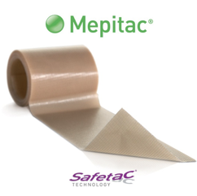
Molnlycke Mepitac Soft Silicone Tape 3/4 X 118 Inch
Purchase online here or at any Medical Supply store

Scar Cream and Sunscreen

- Begin at 3 months post-op
- Use product of your choice as directed
- All products are available on Amazon.com

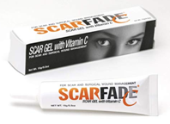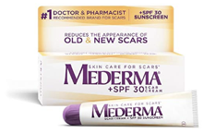

Hanson Medical Scarfade Gel with Vitamin C Maderma Scar Cream Plus SPF

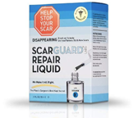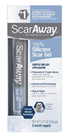
Scarguard Repair Liquid with Vitamin E ScarAway Scar Treatment Gel

