Post-Operative Bra Suggestions

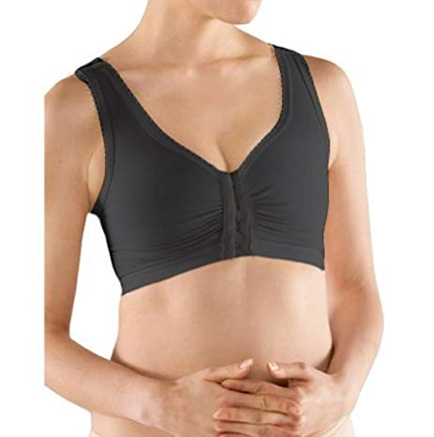

Marena Surgical Bra with 1” Elastic® Champion® Zip-Front Sports Bra - 1699
(F5 Certified Compression Garment)

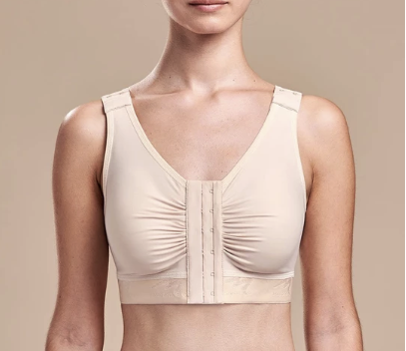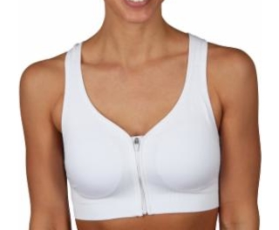
Marena B | Classic Bra-Basic/A-C Cups Jockey Sports Bra: Front-Close High Impact
_ Sports Sizes S-XL, Bra #8656

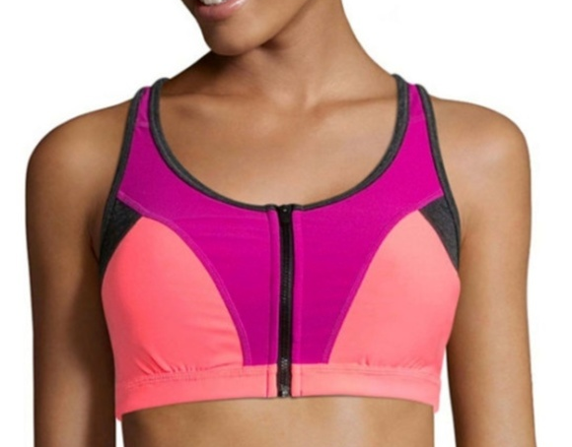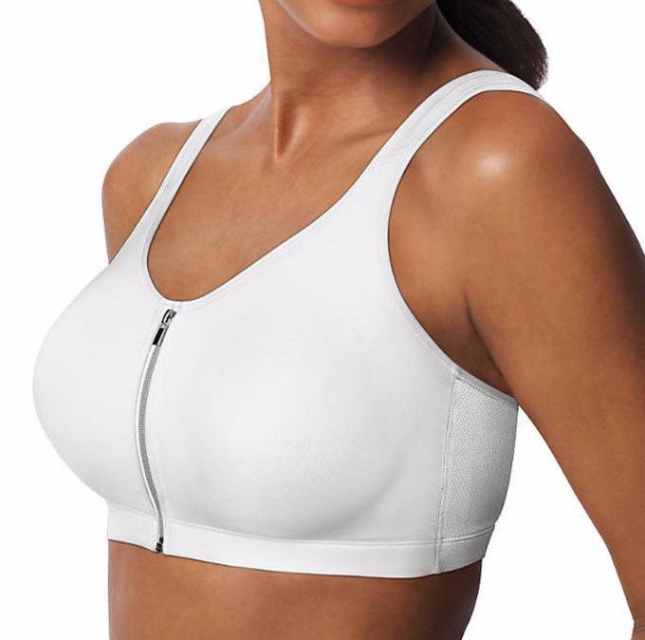

Xersion™ Quick-Dri® High Support Playtex Play® Zip Zip Hurray® Front-Close
Colorblock Zip-Front Bra Sizes XS-XXL Wirefree Bra #25658 Sizes S-2XL

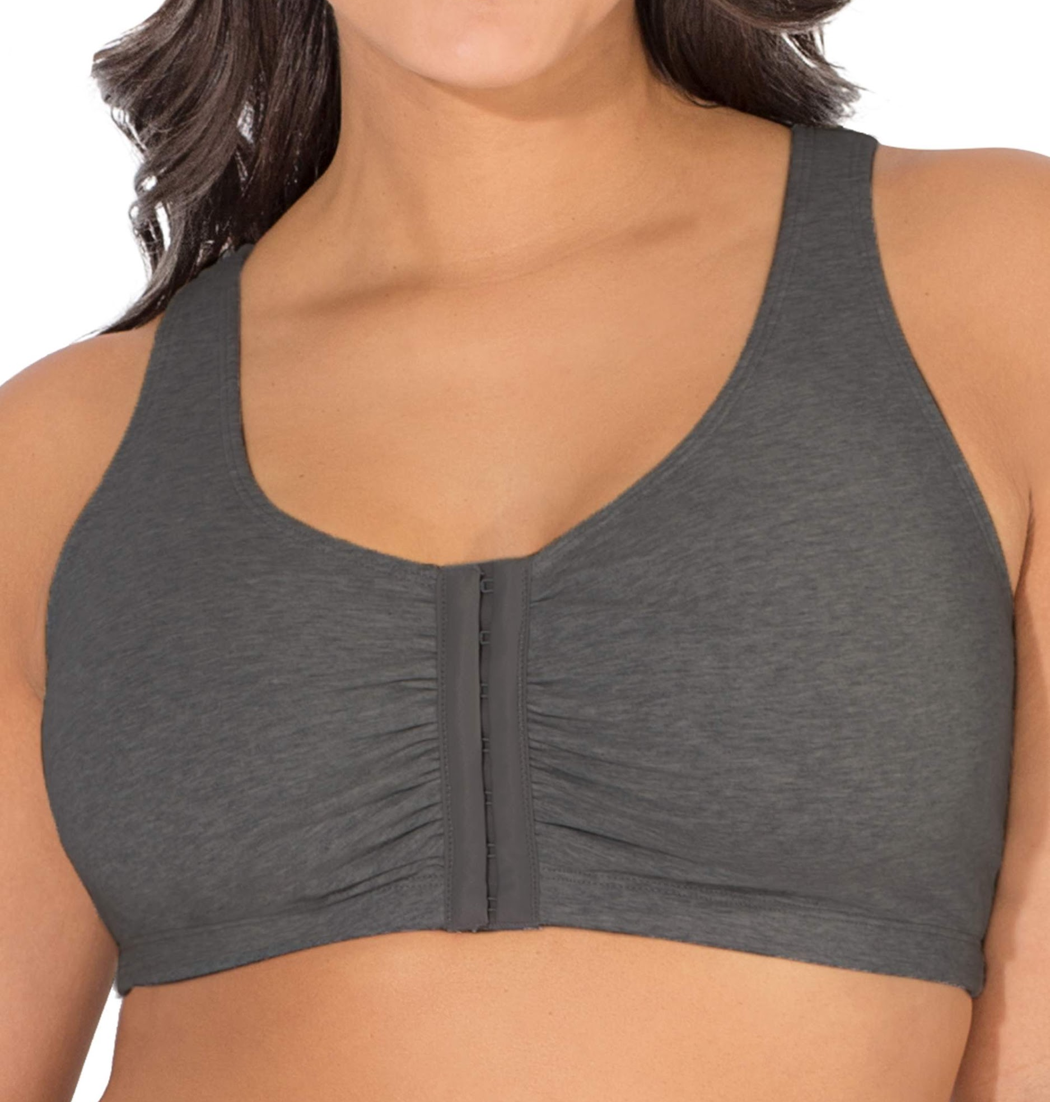
Fruit of the Loom® Comfort
Front-Close Sports Bra, #96014 Sizes 36-48

Please note that all bras fit differently. The idea is to wear something comfortable, snug (not too tight) and supportive (no underwire). Front closures are ideal. If you find something else not listed on this sheet, please feel free to wear it and let us know.

