Breast Implant Massage

Breast implant massage is a vital part of the breast augmentation or implant exchange recovery process. By performing these techniques, you will keep the surgical pocket open and help the scar capsule that naturally forms around the implant soft, supple and larger than the implant, resulting in soft, exceptionally natural looking breast. If the pocket is not kept open, the scar capsule can quickly become thick, rigid, and unyielding, leading to breasts that feel hard, painful and may eventually become distorted.
- Start these Breast Implant Exercises once directed by your physician.
- Perform these Breast Implant Exercises 3 – 4 times a day during the first six weeks of recovery while awake.
- Continue performing these Breast Implant Exercises once a day for the life of your implants.
- During each Breast Implant Exercise, hold the implant in each position for 5-10 seconds.
- The more frequently and correctly you perform these exercises, the easier they become.

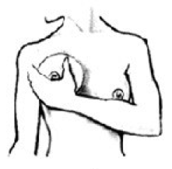
Upward Movement of the Breast Implant
- During this exercise, be sure not to push the entire breast upward; the goal is to slide the implant upward within the pocket while the breast stays in place.
- Place your thumb and forefingers just above the crease along the underside of the lower breast.
- Place the thumb and forefinger of your other hand over the nipple area of the same breast, spanning the entire breast and implant area.
- With both hands, firmly grip the implant using your thumb and forefingers.
- Gently apply pressure, squeezing your forefingers and thumb together to slide the implant upward into the upper borders of the submuscular pocket created during your augmentation.
- Slowly continue to slide the implant upward under the muscle pushing it toward the collarbone.
- Press firmly down along the top of the implant, returning it to its original position.

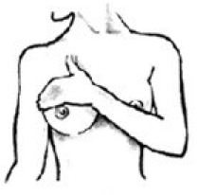
Downward Movement of the Breast Implant:
- Place your hand, fingers flat and closed on the upper portion of your breast just above the nipple.
- Firmly but gently apply pressure to force the breast implant downward until it slides fully back down into the lower area of the pocket and rounds out along the lower breast fold.
- Return the implant to its original position.

Outer Movement of the Breast Implant (Outside & Cleavage):
- Cup your hand directly over the opposite breast and feel for the implant.
- Grasp the implant from the side and gently move it toward your midline until it rounds out along the cleavage area of the breast.
- Next, slide the implant outward until it has rounded out on the opposite side of your body in the other direction.
- Perform these steps on each breast moving the implants both to the right and left.
- Return the implant to its original position.
