Drain Tube Care

A Jackson Pratt drain, or JP drain, is used to remove fluids that build up in areas of your body. Unwanted fluid can collect in areas of infection, areas where surgery has been done, or in other body areas. The JP drain is made up of a thin rubber tube and a soft round squeeze bulb. One end of the rubber tube is placed in the area where body fluids may build up. The other end sticks out of your body through a small incision, and is connected to the squeeze bulb.

General care:
- Drains commonly remain in place for 5-10 days; however, this is all dependent on the type of surgery performed and the patient as everybody responds differently.
- The final decision for drain removal is determined based on drainage output. When the drainage amounts have fallen to an acceptable amount, we will schedule you for removal.
- Strip and Empty drains every 4-6 hours and record the drainage amounts on your log form.
  - VERY IMPORTANT: Keep a consistent 4-6 hour schedule (ex: breakfast, lunch and dinner as well as before bed if the bulb is full) so we can accurately monitor your drainage amounts as they decrease. If you have more than one drain, be sure to record each drain separately. DO NOT combine the amounts.
- Record your drain amounts on the log provided and bring the log with you to all follow up appointments.
- Hygiene: You can shower with drains in place unless instructed otherwise by your provider. Do not submerge the drain sites or incisions in standing water (Ex: bath tubs)
  - If a Tegaderm (clear plastic) bandage is in place over your drain site, leave it in place. You may shower with it intact. This may fall off which is ok. Simply apply a small amount of bacitracin ointment over the site where the tube comes out of your skin and cover with gauze after your shower.
  - If the area is covered with gauze and tape, you can remove the drain bandages prior to your shower. Gently clean around your drain site and incisions with soap and water. Once done, pat the area dry with a towel, apply a thin layer of bacitracin ointment (over the counter), and cover with a clean piece of gauze and tape.

Call during normal business hours if:
- The drainage amount suddenly drops or increases over 100 mL in 24 hours
- The drain tube falls out
- You cannot keep the bulb compressed

Call our office immediately if you have:
- Bright red drainage that was previously darker or clear/pink/orange
- Cloudy drainage into the tube and bulb
- Fever of 101ºF (38.3ºC) or higher
- Increased redness, swelling, tenderness, or pus at the drain insertion site
How to empty the JP drain:
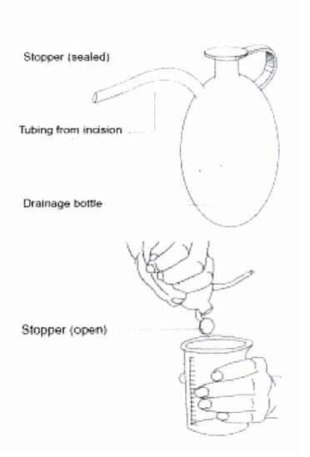
- Wash your hands with soap and water.
- Remove the plug stopper on the bulb and pour the fluid into a measuring container being careful not to touch the spout.
- Gently squeeze the bulb and pour the fluid into the measuring cup and set aside.
- Squeeze the bulb until the bulb is completely compressed. Close the stopper to maintain suction. Check to see that the bulb remains fully compressed to assure gently suction.
- Pin the collar of your JP drain securely to a piece of clothing (bra, abdominal binder, pants waist, etc.) or feed it through the Velcro straps attached at the bottom of your bra or binder. DO NOT let the drain dangle!
- Record the amount and appearance of the fluid in the measuring cup on your log.
- Discard the fluid in the toilet and wash hands. Rinse the measuring container with water.
- At the end of the day, add the total drainage for the 24-hour period and record it on your log.
- If you have more than one drain, be sure to record them separately.

“Stripping or Milking the drain” to prevent clots in the tube
- Wash hands with soap and water
- At the point closest to the insertion point, pinch and hold the tubing between the thumb and forefingers.
- Slide fingers down the tubing towards the bulb, pushing any fluid or clot towards the bulb.
* The tube will compress and stay flat after you have stripped all the fluid into the bulb
* Moistening your fingers with lotion or using an alcohol wipe will help slide your fingers down the tube.
- Repeat steps 2-3 as necessary to dislodge any clot.
- Fluid may leak from the drain exit site on the skin if there is a clot blocking drainage flow.
If there is fluid in the bulb and no leakage from the skin, the drain is working properly in spite
of what appears to be a clot.

